Type | Bias | Price | Oscillator | Description
Regular | Bullish | Lower Low | Higher Low | Indicates underlying strength. Bears are exhausted.  Warning of possible trend direction change from downtrend to uptrend.

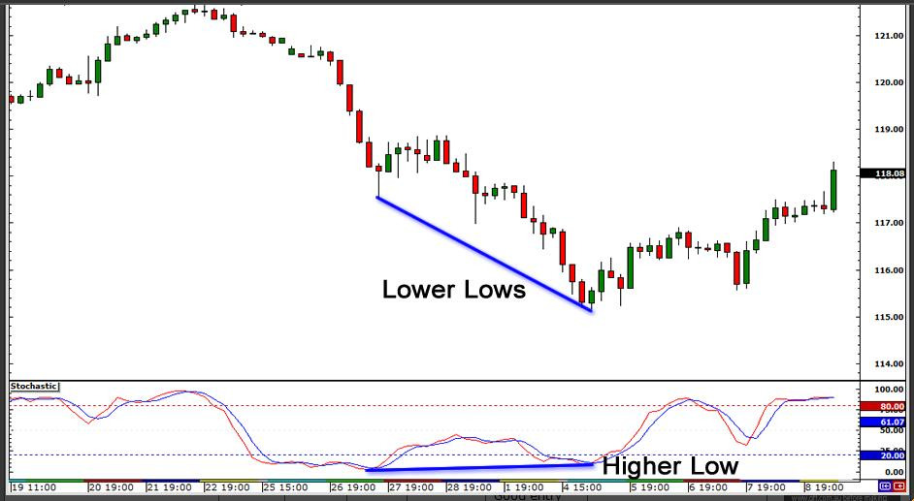

Type | Bias | Price | Oscillator | Description
Regular | Bearish | Higher High | Lower High | Indicates underlying weakness. Bulls are exhausted.  Warning of possible trend direction change from uptrend to downtrend.

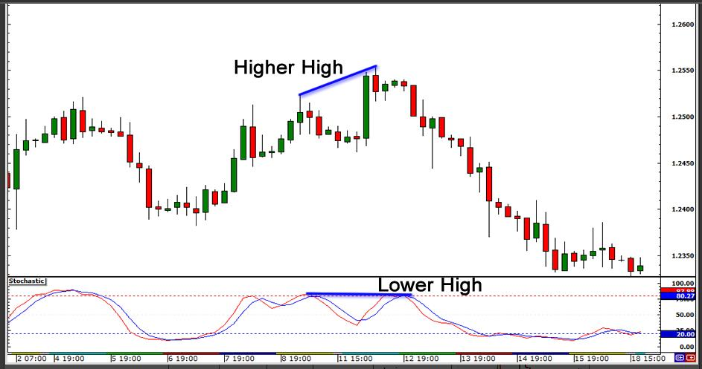

Type | Bias | Price | Oscillator | Description
Hidden | Bullish | Higher Low | Lower Low | Indicates underlying strength. Good entry or re-entry. Occurs during retracements in an uptrend. Nice to see during price retest of previous lows. "Buy the dips"

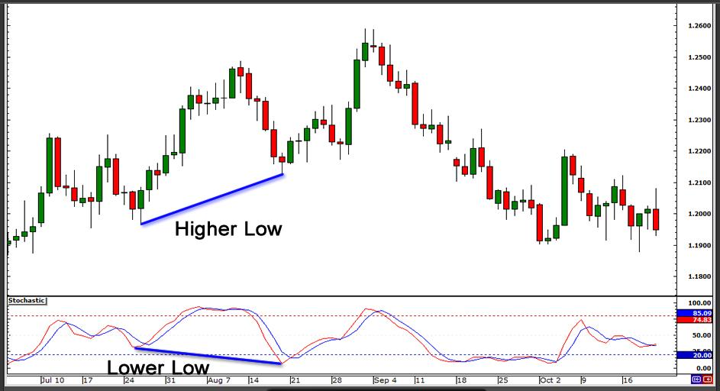

Type | Bias | Price | Oscillator | Description
Hidden | Bearish | Lower High | Higher High | Indicates underlying weakness. Found during retracements in a downtrend. Nice to see during price retests of previous highs. "Sell the rallies"

